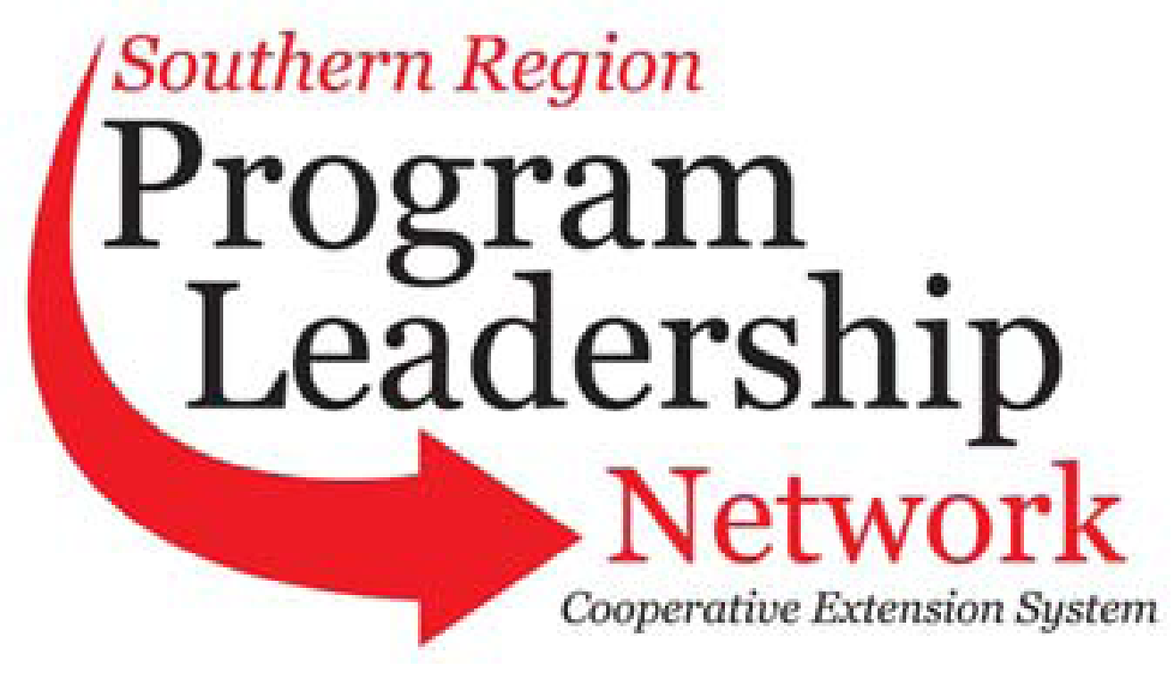
September 1, 2026 – August 31, 2027
(See submission instructions at end of document)

Committee Name | CRD - PLN | Submission Contact Name: | Mark Rendleman
Chair | Mark Rendleman, OH | Submission Contact E-mail | mrendleman@centralstate.edu
Vice-Chair | Rachael Carter, MS | Submission Contact Phone | 513-218-8231
Secretary | Courtney Howard, GA | Date of Submission | 8/20/2025
PLC Representative 1862 | Sreedhar Upendram (2027) | PLC Representative 1890 | Terence Norwood, AL (2028)
1862 Advisor | Tom Dobbins | 1890 Advisor | Jennifer Wells Marshall

Annual Plan of Work
September 1, 2025 – August 31, 2026

Item to Accomplish | Responsibility  (Names of people assigned to item) | Key Contact  (Person who will serve as a key contact for item) | Goal Date  (Anticipated completion date) | Completion Date  (to be filled in when completed)
Collect, share, and expand CRD indicators, programming and resources via SRDC’s Around the South newsletter and annual report. | All program leaders, Contacts - Roseanne Scammahorn, Grace Langford | Grace Langford, Roseanne Scammahorn | July, 2027
Hold indicator training to understand/ expand indicator reporting and response. | Linda Seals, ChaNae Bradley, Melissa Bond, Carla Adams Lippett, Adam Hodges, Stacey McCullough, Kimberly Davis | Linda Seals | July 2027
Adopting/implementing regional multi-state entrepreneurship program | Terence Norwood, Roseanne Scammahorn, Krystle J. Allen, Jimmy Henry, Rachael Carter, Adam Hodges, Gill Finley, James Barnes, James Arati, Al McIntosh, Chrystol Thomas, Heather McMillae, Shante Ellis, leonard Githirji | Terence Norwood | July 2027
Provide Community Development Foundations training (CD 101) for ALL Extension professionals by developing a delivery model. | Hunter Goodman, Sreedhar Upendram, Dan Kahl, Natriez Peterson, ChaNae Bradley, Michelle Eley, Rachael Carter, Stacey McCullough, Jimmy Henry, Carla Adams Lippett, Linda Seals, Rori Hernandez, Ana Gouge, Leah Carter, Shante Ellis, German Ramos, Iris Crosby | Hunter Goodman /Sreedhar Upendram | July, 2027
Host a virtual training series focused to strengthen Extension capacity and increase external resource opportunities for community programs. | Shante Ellis, Kenny Sherin, Iris Crosby, Krystle J. Allen, ChaNae Bradley | Iris Crosby, Kenneth Sherin | July, 2027

Quarterly Conference Call Schedule: (Dates/Times – Please indicate time zone)

Nov. 12, 2026
Feb. 11, 2027
April 8, 2027
July 8, 2027

All calls at 2:00pm ET/1:00pm CT

To add more lines, if needed: Place cursor in last box of the last row. Hit “tab.” Another row should appear.
Submission instructions:
Rename the document with your committee name initials (ANR, CRD, COM, FCS, 4H, ITS, MM, PSD, PLC) such as: ANRplanofwork.doc
Email document to HYPERLINK "mailto:r.scammahorn@msstate.edu"r.scammahorn@msstate.edu
If you have problems, contact Roseanne Scammahorn at HYPERLINK "mailto:r.scammahorn@msstate.edu"r.scammahorn@msstate.edu

